 **WALTER LEE ELEMENTARY SCHOOL**

9491 Ash Street, Richmond, B.C. V7A 2T7

Telephone: 604-668-6269 Fax: 604-668-6414

Website: [**www.sd38.bc.ca/Lee**](http://www.sd38.bc.ca/Lee)

Email: [**lee@sd38.bc.ca**](mailto:lee@richmond.sd38.bc.ca)

Safe Arrival: 604-668-6269 & press 1

Principal: Mr. A Chan School Trustee Liaison: Ms. A. Wong



February 5, 2024

Dear Grade 5/6 Students and Parents:

Our school has a tradition of involving Grade 6 and 7 students in an outdoor education program. This experience is offered every second year so that all Grade 6 and 7 students will have an opportunity to participate. SAVE THE DATE, This upcoming outdoor education will take place at the beginning of the 2024/25 school year scheduled for October 9-11, 2024. In the past Walter Lee school has attending outdoor education in June. We are making an adjustment because we are interested in experiencing camp at the beginning of the school year with the intention of using a collective experience to foster relationships and team building.

Our school will be going to Camp Elphinstone, which is located on the Sunshine Coast, close to Langdale. We will be traveling by school bus and BC Ferries to and from the camp. The bus will leave the school early morning on Wednesday, and we will be back at the school Friday afternoon. Specific times will be provided closer to the date.

Walter Lee staff members will accompany our Grade 6 and 7 students to supervise and support this outdoor education program delivered by the staff of Camp Elphinstone. During the day, students will be involved in activities such as orienteering, kayaking, canoeing, archery, high and low ropes courses, rappelling and hiking.

This outdoor education experience includes all transportation, meals, accommodation, and complete programming by trained instructors at an estimated cost of $350.00 per child. We are hopeful that through fundraising efforts we will be able to lower the cost for families.

More information and parent info sessions are being schedule; we will share that information with you when it become available.

Please feel free to log onto <https://www.gv.ymca.ca/about-ymca-camp-elphinstone> for more information about the camp itself.

Sincerely,

Mr. Alfred. Chan

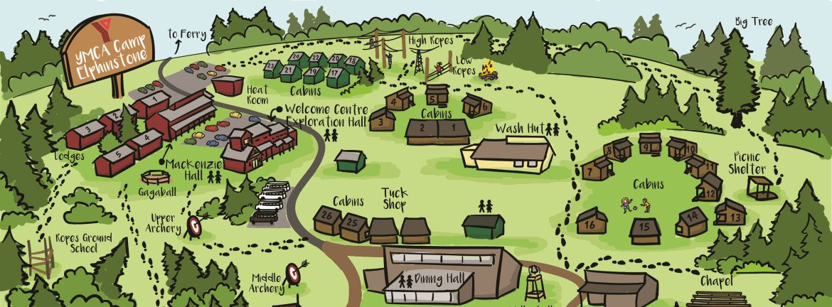Principal

Walter Lee Elementary